Library Name: | cgm
Cell Name: | NAND2XI
Function/Truth Table:
A B |  | Y
0 0 |  | 1
0 1 |  | 1
1 0 |  | 1
1 1 |  | 0
Propagation Delay (path based): with extracted parasitic
Transition |  | Delay (s)
A → Y ↑ (T_PLH) |  | 1.122n
A → Y ↓ (T_PHL) |  | 1.687n
B → Y ↑ (T_PLH) |  | 1.214n
B → Y ↓ (T_PHL) |  | 1.692n
Output Rise Time (path based):
Transition |  | Rise Time (s)
A → Y ↑ |  | 2.438n
B → Y ↑ |  | 2.436n
Output Fall Time (path based):
Transition |  | Fall Time (s)
A → Y ↓ |  | 3.243n
B → Y ↓ |  | 3.244n
Layout Height: 1.71µm
Layout Width: 0.8µm
Layout Area: 1.368µm²
Symbol with Port Names:

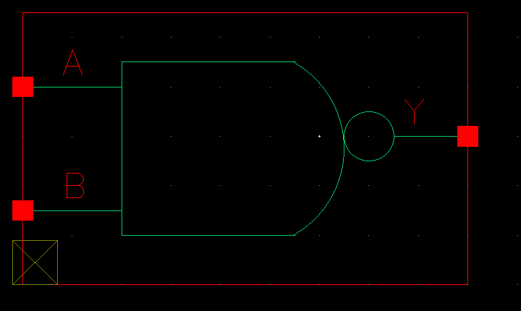
Schematic:

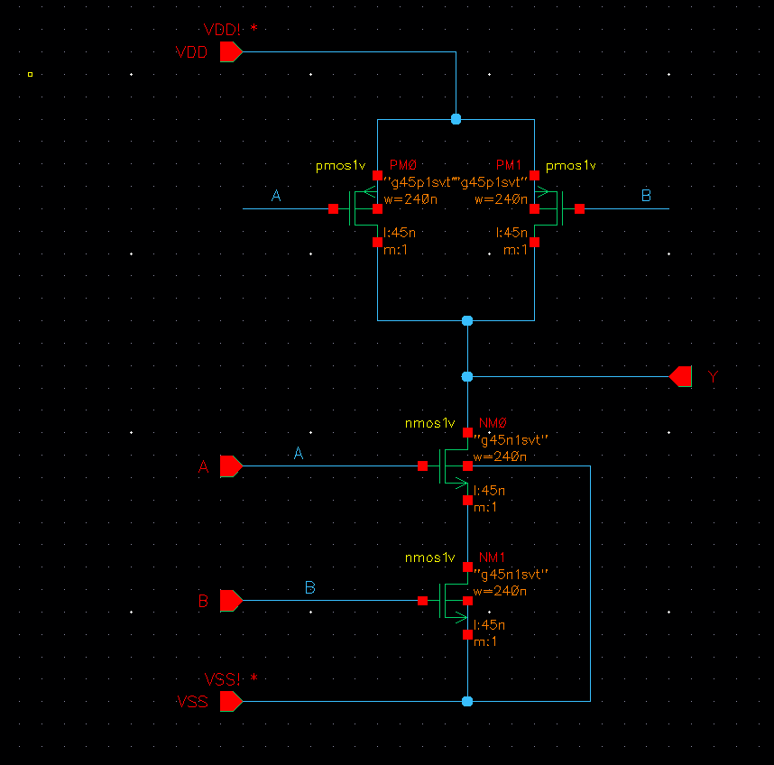
Layout:
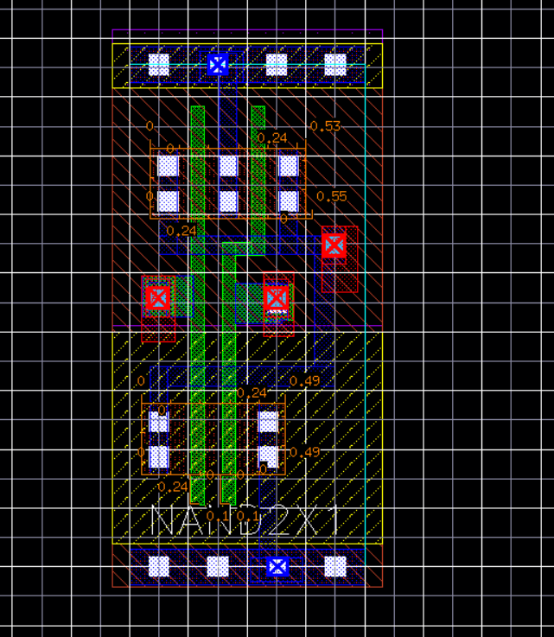

Functional Simulation Waveforms
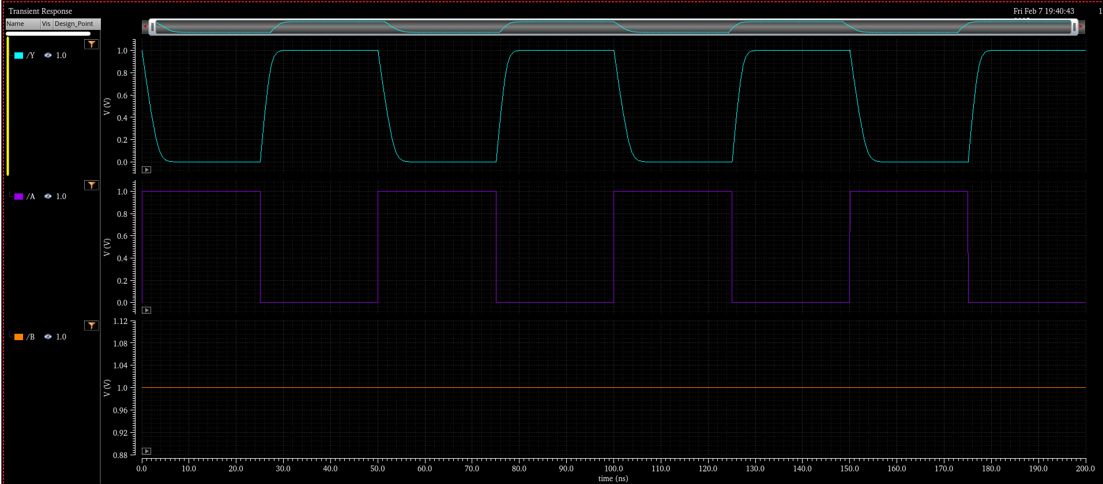

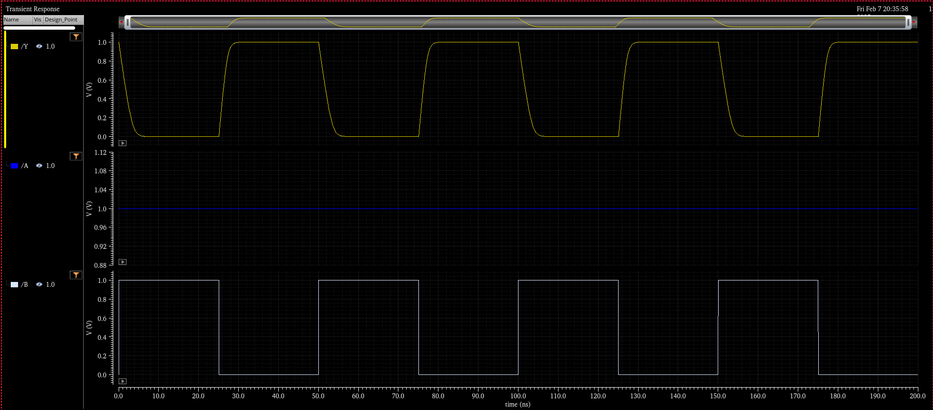

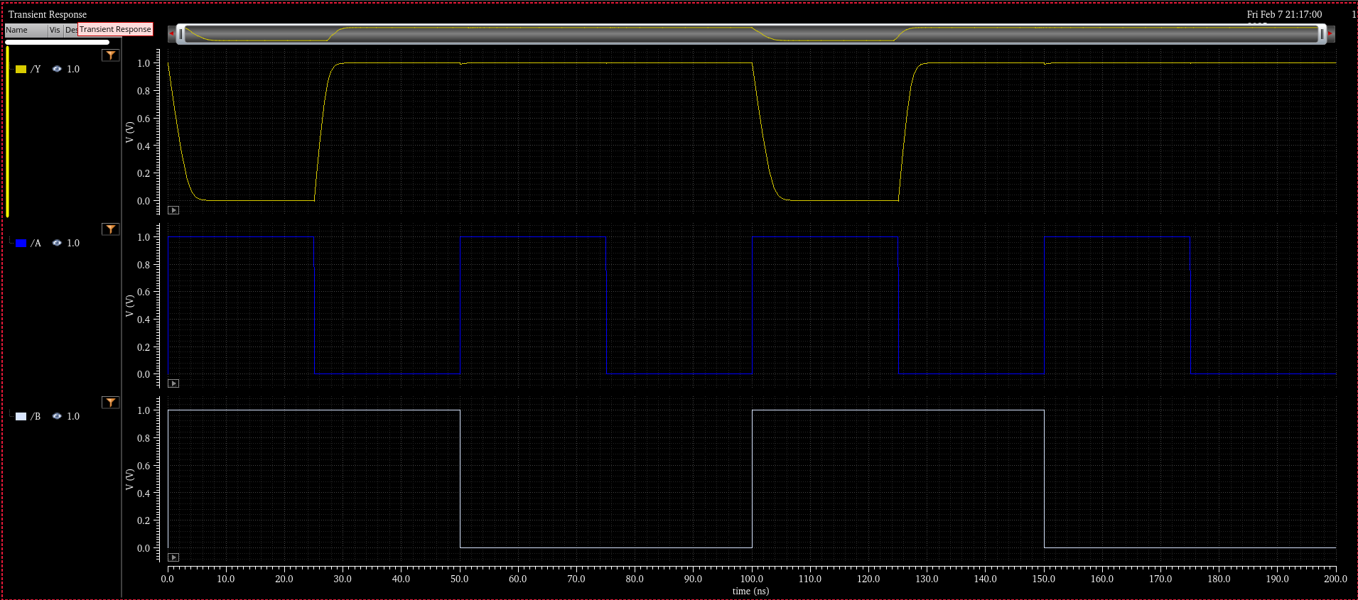
Comments/Notes:

The NAND2X1 gate with extracted parasitics was successfully tested, confirming correct functional verification. However, the timing results show an increase in delays compared to the pre-layout simulation, indicating the impact of parasitic resistances and capacitances from interconnects and device structures.

